# EE654 – Adaptive Algorithms, Homework Assignment #1

a)

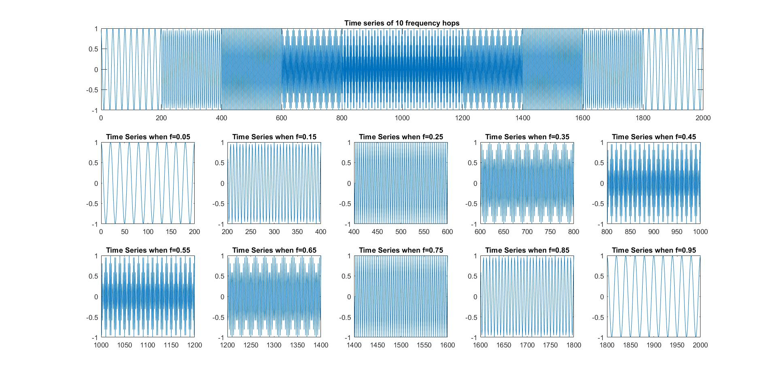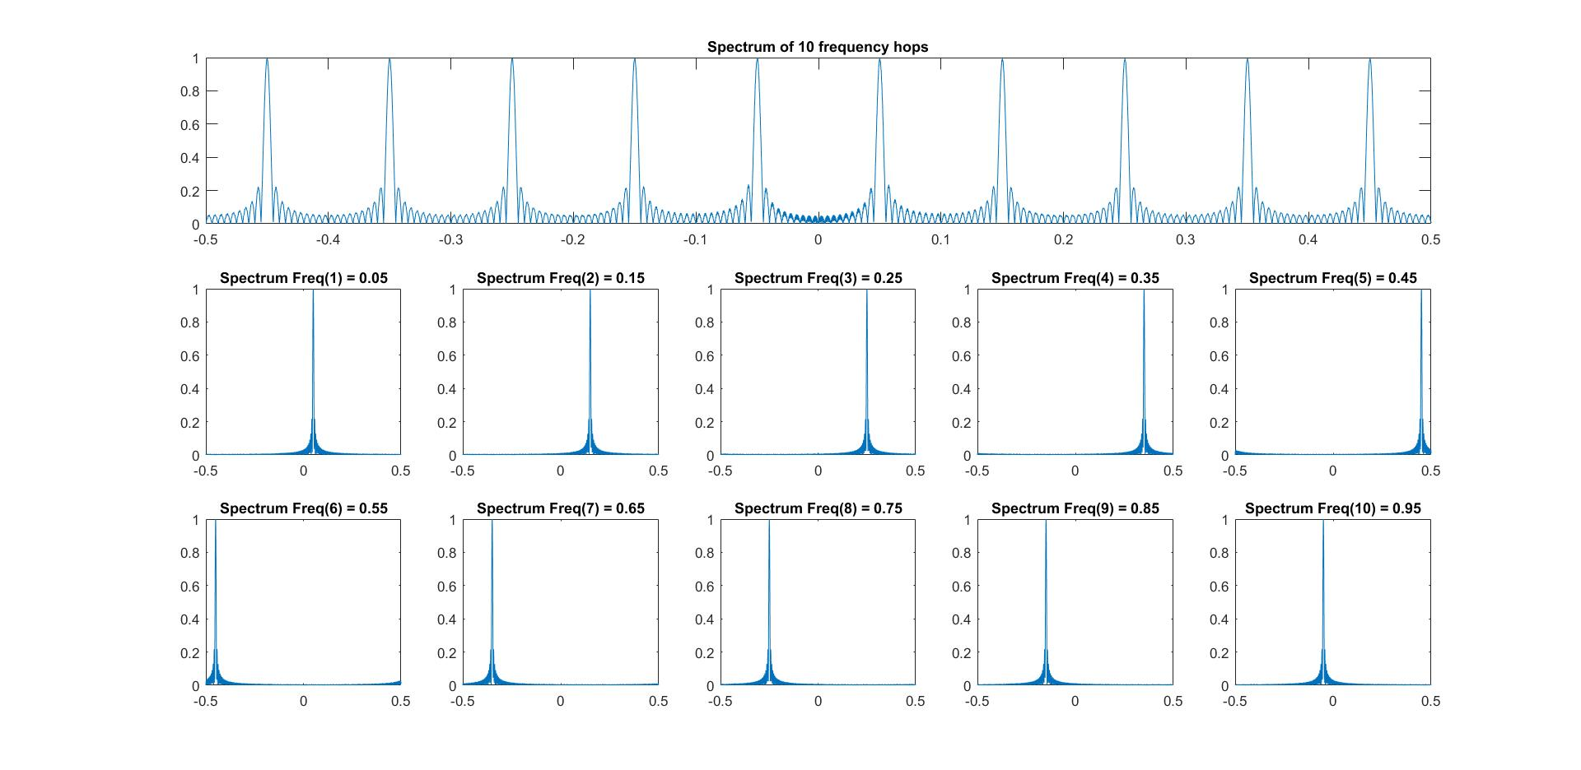

x=ones(1,200);

x1=[0.05*x 0.15*x 0.25*x 0.35*x 0.45*x 0.55*x 0.65*x 0.75*x 0.85*x 0.95*x];

x2=filter(1,[1 -1],x1);

x3=exp(j*2*pi*x2);

N =2048;

i = 1;

fs = figure;

subplot(3,5,1:5)

X3 = fft(x3,4*N);

plot(linspace(-0.5,0.5,4*N), fftshift(abs(X3/max(X3))))

title('Spectrum of 10 frequency hops')

ts = figure;

subplot(3,5,1:5)

plot(0:length(x3)-1,x3)

title('Time series of 10 frequency hops')

for k = 1:200:2000

f = linspace(-0.5,0.5,N);

index = k:k+199;

figure(ts)

subplot(3,5,5+i)

plot(index, x3(index))

title(['Time Series when f=' num2str(x1(k))])

X3temp =fftshift(abs(fft(x3(index),N)));

figure(fs)

subplot(3,5,5+i)

plot(f,X3temp/max(X3temp))

title(['Spectrum Freq(' num2str(i) ') = ' num2str(x1(k))])

i = i+1;

end

b)

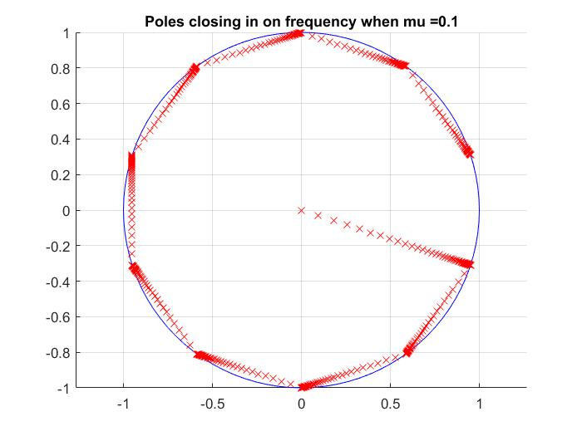

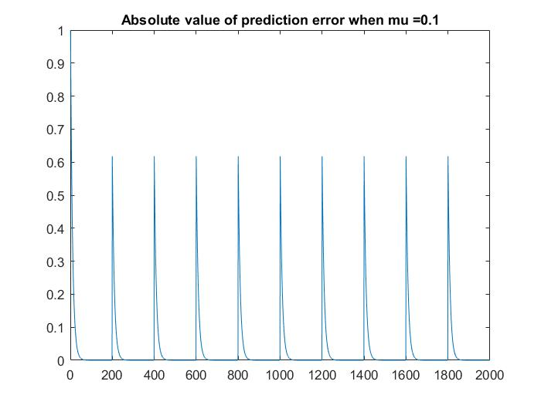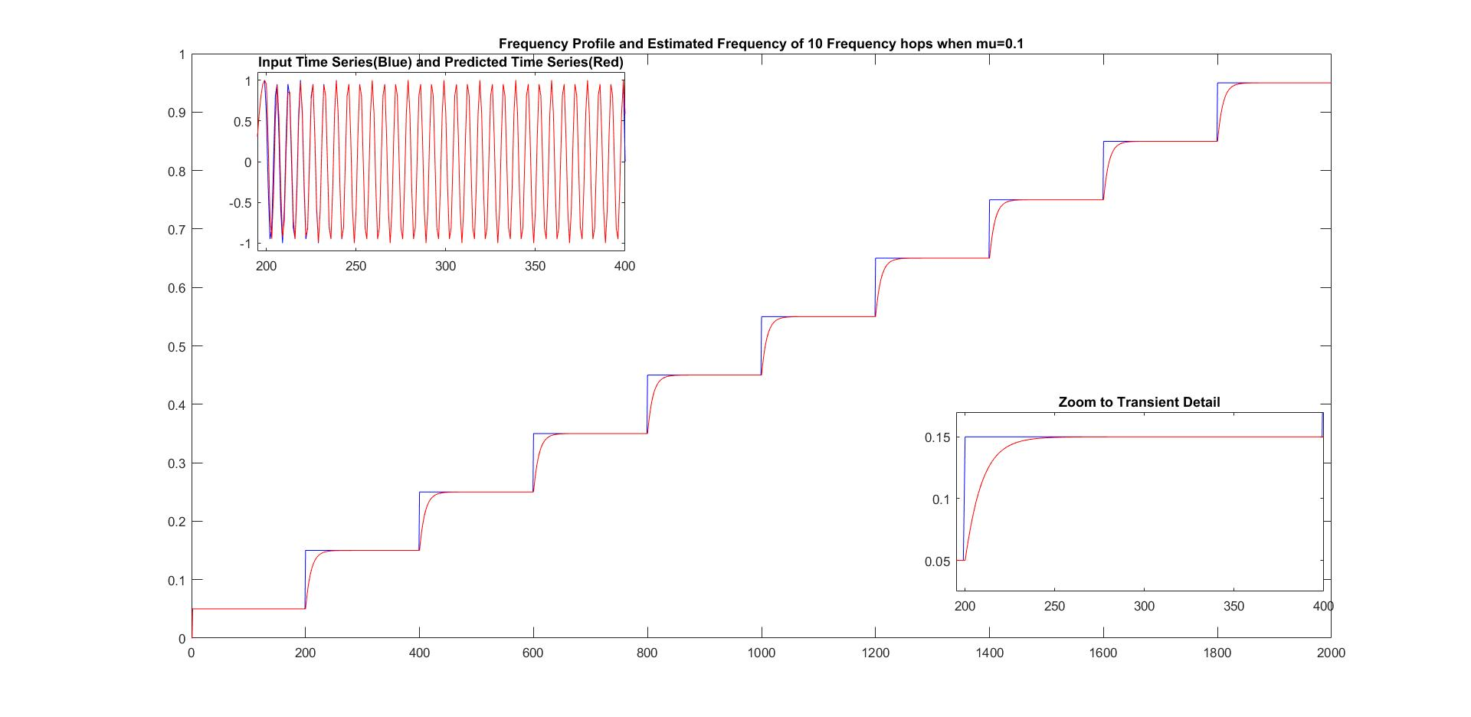

To solve this problem, two functions were created. The first one, **line_canceller()** takes an input and a mu value, and returns vectors for weights, predictions, and errors. The code follows:

function [ws, ps, errs] = line_canceller(x3, mu)

%line_canceller One-tap adaptive line canceller

% Computes the adaptive line canceller algorithm for a sinusoid input.

% Returns the weights, predictions, and errors for each sample.

w = 0;

w_new = 0;

input_reg = 0;

w_sv = zeros(1,length(x3));

p_sv = zeros(1,length(x3));

err_sv = zeros(1,length(x3));

for nn = 1:length(x3)

w = w_new;

w_sv(nn) = w;

p = conj(w)*input_reg;

p_sv(nn) = p;

err = x3(nn) - p;

err_sv(nn) = err;

w_new = conj(err)*input_reg*mu+w;

input_reg=x3(nn);

end

ws = w_sv;

ps = p_sv;

errs = err_sv;

end

The second function, **plot_results(),** takes the results obtained from **line_canceller()** and produces the plots that were required for the problem. The code follows:

function [null] = plot_results(x1,x3,ws,ps,errs,mu,str)

%plot_results Plots results of adaptive line canceller.

figure

pos = [-1 -1 2 2];

unitcircle =rectangle('Position',pos,'Curvature',[1 1]);

set(unitcircle,'edgecolor','b');

axis equal

grid on

hold on

plot(ws,'rx')

title(['Poles closing in on frequency when mu =' num2str(mu) str])

figure

plot(0:length(x1)-1,x1, 'b')

hold on

plot(0:length(ws)-1,unwrap(angle(ws))/(-2*pi),'r')

title(['Frequency Profile and Estimated Frequency of 10 Frequency hops when mu=' num2str(mu) str])

axes('position',[0.65 0.175 0.25 0.25])

box on

plot(195:400,x1(196:401),'b')

hold on

plot(195:400,unwrap(angle(ws(196:401)))/(-2*pi),'r')

xlim([195 400])

ylim([0.025 0.17])

title('Zoom to Transient Detail')

axes('position',[0.175 0.65 0.25 0.25])

box on

plot(195:400,x3(196:401),'b')

hold on

plot(195:400,ps(196:401),'r')

xlim([195 400])

ylim([-1.1 1.1])

title('Input Time Series(Blue) and Predicted Time Series(Red)')

figure

plot(0:length(errs)-1,abs(errs))

title(['Absolute value of prediction error when mu =' num2str(mu) str])

end

And this is the script which runs these functions with the parameters given in the problem.

mu = 0.1;

[ws ps errs] = line_canceller(x3, mu);

plot_results(x1,x3,ws,ps,errs,mu,'')

c)

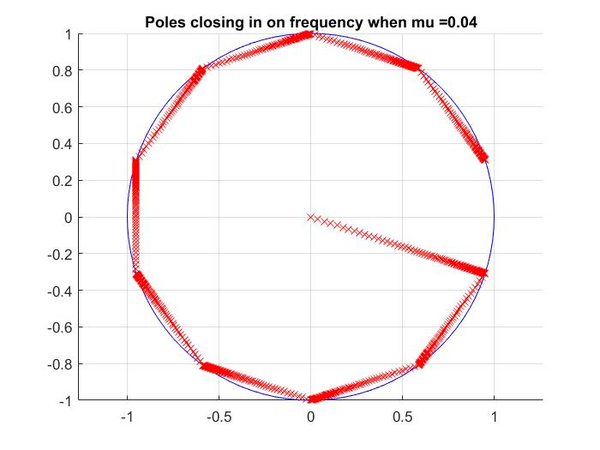

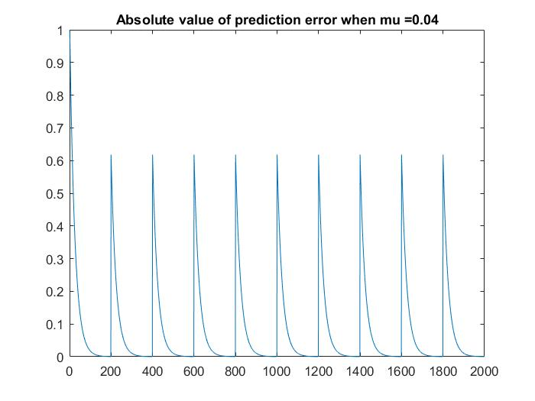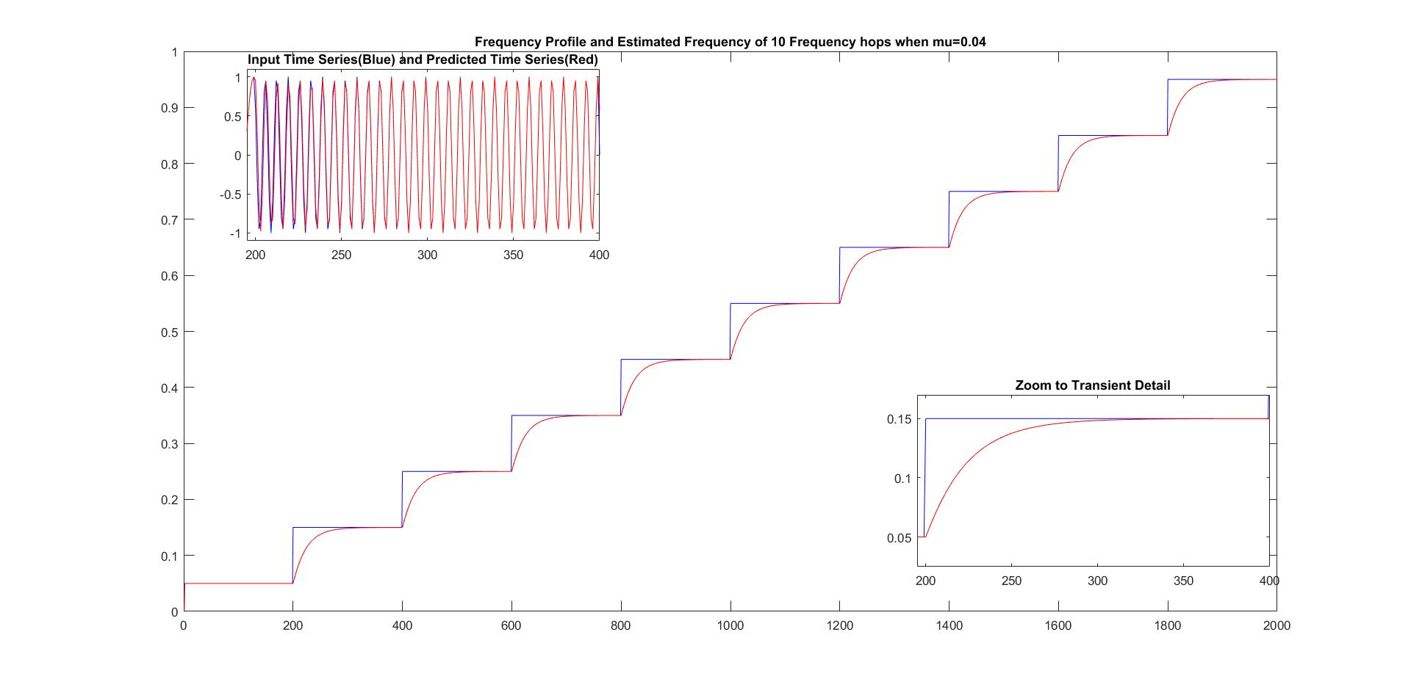

For this task, the same functions as in b) were used, but with different parameters.

mu = 0.04;

[ws ps errs] = line_canceller(x3, mu);

plot_results(x1,x3,ws,ps,errs,mu,'')

d)

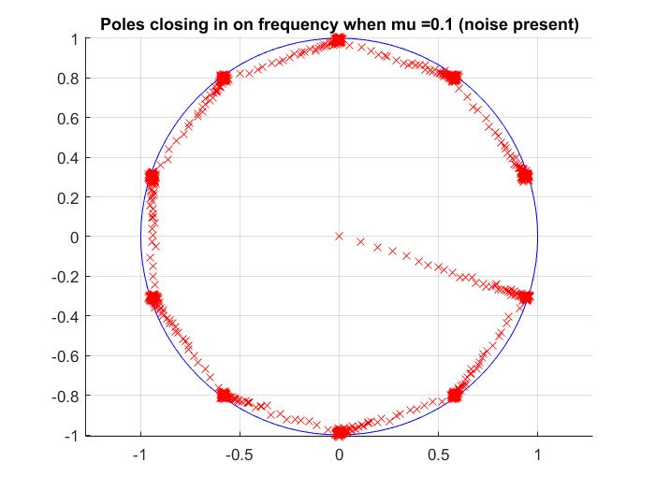

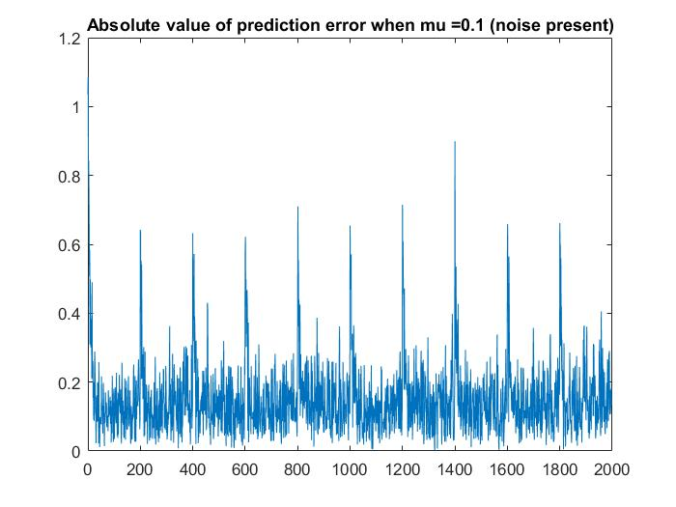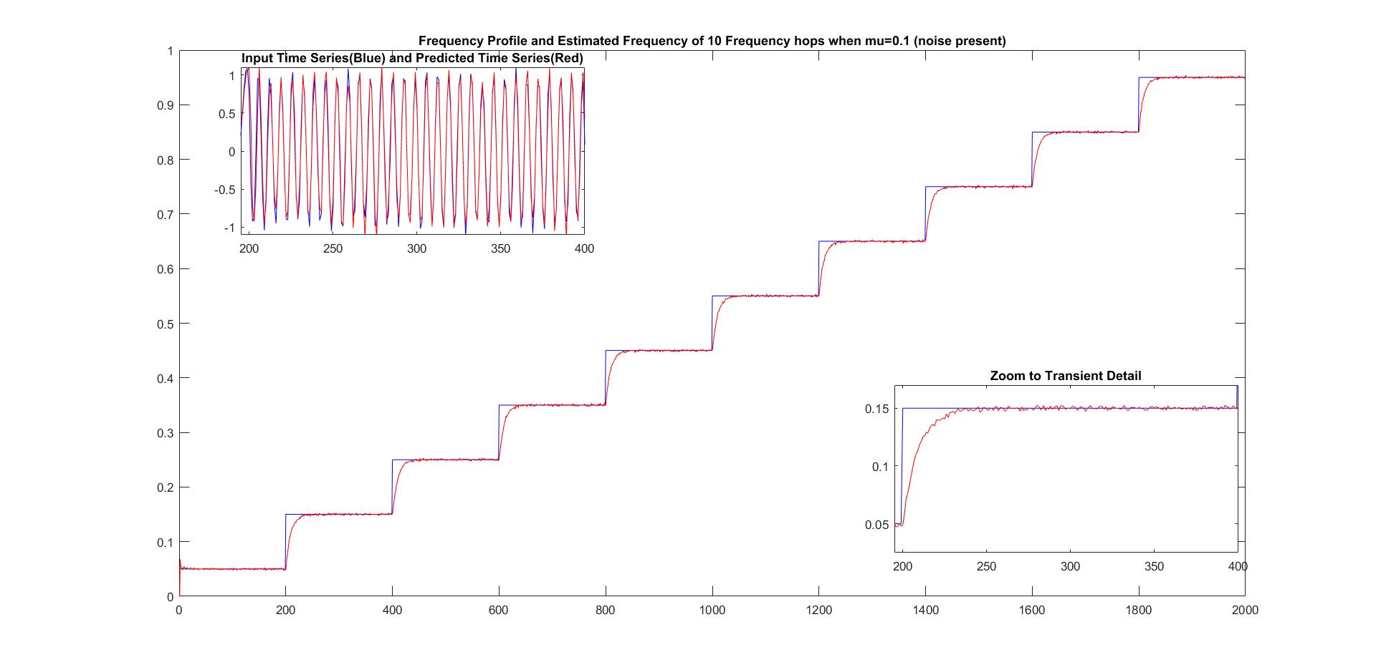

For this task, the same functions as in b) were used, but with different parameters.

X4=x3+0.1*(randn(1,2000)+j*randn(1,2000))/sqrt(2);

mu = 0.1;

[ws ps errs] = line_canceller(X4, mu);

plot_results(x1,x4,ws,ps,errs,mu,' (noise present)')

e)

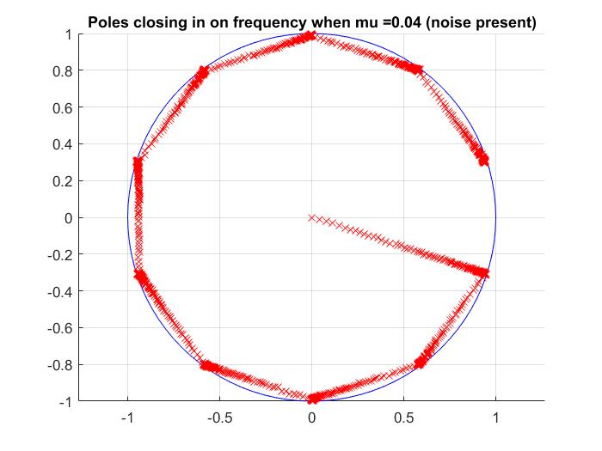

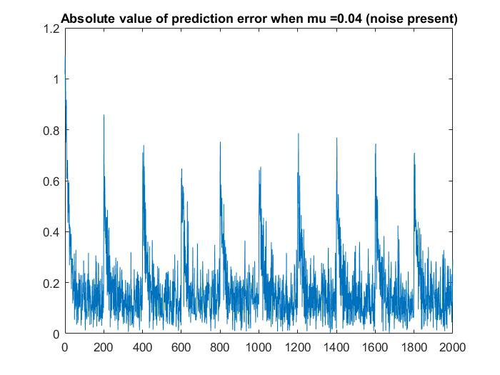

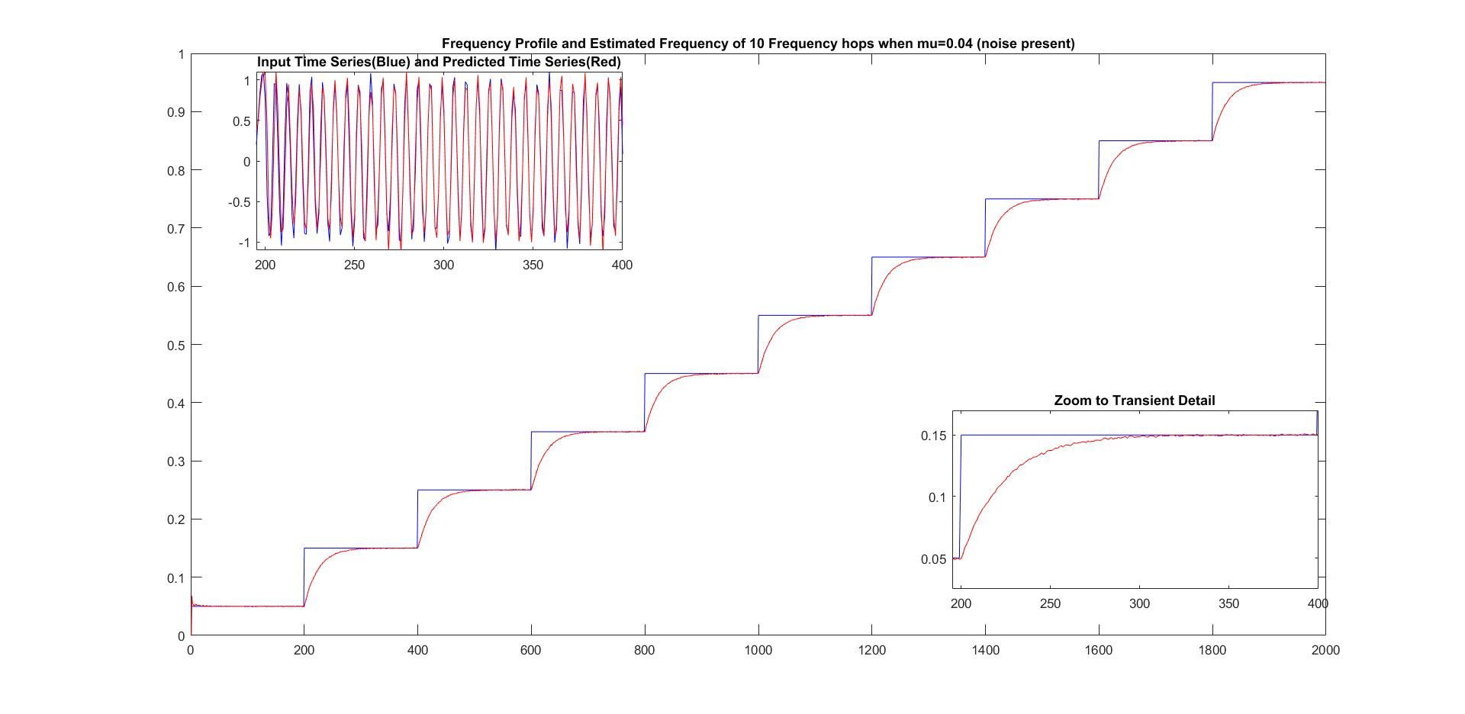

For this task, the same functions as in b) were used, but with different parameters.

mu = 0.04;

[ws ps errs] = line_canceller(X4, mu);

plot_results(x1,X4,ws,ps,errs,mu,' (noise present)')